TITLE: Instruction for Inspection and Testing of `PWM CUM DRIVER CONTROLLER PCB ASSEMBLY’ (On Common Test Jig) for 017.01.008.0320, 017.01.008.0366

- SCOPE

1.1 Applicable for testing of PWM CUM DRIVER controller PCB Assy. as per BOM 017.01.008.0320, 017.01.008.0366

- DETAILS OF THE INSTRUCTION

2.1 Inspection / Measuring / Test Equipment. :

2.1.1 Test set up as per circuit diagram No. CK79/908/A.

    - Digital Multimeter.

2.1.3 4 Channel Oscilloscope.

2.2 Record the test results in the test report as the testing
Progresses (REF: INSP4437/I5/R2).

2.3 Sample size = 100 %.

2.4 In the case of any nonconformity at any stage of inspection and testing,
Refer to the procedure NCCR2001.

  - For visual inspection and vibration test refer to the inspection instruction INSP3207.

  - ELECTRICAL TEST:

2.6.1 Connect the PCB under test, as per the given control PCB connection diagram
(CK79/908/A).

    - Connect 4-channel Oscilloscope at G1&E1, G2&E2, G3&E3 and G4&E4 terminals.

    - Put MMA/TIG switch in MMA Mode.

    - Put Over Current Protection switch (S7) in OFF Condition

    - Put the Current Reference Pot (POT10) at maximum position and & Current Feedback Shunt Pot (POT3) at minimum position.

    - Switch ON power Supply to Test Jig

Now check the following test points on PWM CUM DRIVER control PCB as per given table
SR.NO. | LOCATION | ACCEPTANCE  CRITERIA |  | REMARKS
1. | Check TP1 Voltage w.r.t TP2 (Gnd). | +14.4 to +15.6V Volts (Min to Max) |  | This is for guideline Actual voltage depends on regulator output voltage.
2. | Check TP3 Voltage w.r.t TP2 (Gnd). | -14.4V to -15.6V Volts (Min to Max) |  | This is for guideline Actual voltage depends on regulator output voltage.
3. | Check TP12 Voltage w.r.t TP2 (Gnd). | +14.4 to +15.6V Volts (Min to Max) |  | This is for guideline Actual voltage depends on regulator output voltage.
4. | Check TP10 & TP11 Voltage w.r.t TP2 (Gnd). i.e. for IC U9 pins no 11 and 14 for PWM output Waveforms Voltages w.r.t TP2 (Gnd). | - 5.50V to 6.5V Volts (Min to Max)  - Frequency should be |  | Voltage & Frequency to be checked on Digital Multimeter/ Oscilloscope
4. |  | PCB Assy. Code: | Frequency
4. |  | 017.01.008.0320  017.01.008.0366 | 15.5 to 17.0 KHz
5. | Waveform at TP10 w.r.t TP2 (Gnd). | As per sample waveform attached |  | Oscilloscope settings.  10 V/ Div, 20 μsec/ Div
6. | Waveform at TP11 w.r.t TP2 (Gnd). | As per sample waveform attached |  | Oscilloscope settings.  10 V/ Div, 20 μsec/ Div
7. | Waveform At TP10 and TP11 w.r.t TP2 (Gnd). | As per sample waveform attached |  | Oscilloscope settings.  10 V/ Div, 5μsec/ Div
8. | Check TP4 (Ref. Voltage) w.r.t TP2 (Gnd). | 5.0V to 5.2V |  | This is only for guideline.
9. | Check the TP8 Voltage w.r.t TP2 (Gnd). | 0V (+/-0.3V) --> Current Reference Pot (POT10) at min position  4.4V (+/-0.3V) --> Current Reference Pot (POT10) at max position |  | Keep the P2 pot at max position by rotating in clockwise direction.
10. | Check TP5 Voltage w.r.t. TP2 (Gnd) | 0 to -6 (+/-0.5V) --> V DC |  | This is only for guideline
11. | Check TP7 voltage w.r.t. TP2 (Gnd) | -17mV |  | If not adjust -17mV by Trimmer Pot P3 on control PCB

    - TRIP MODE TESTING: -

Put MMA/TIG switch in TIG Model
Put Current Reference Pot (POT10) & Voltage feedback Pot (POT1) at maximum Current Feedback Shunt Pot (POT3) at minimum position,
- Shunt down Trip Test: -
- Switch On switch S10 (shut down), Observe the PWM waveform will get disappear.
- That means trip error is ok

- Input Over Current Trip Test :-
- Now set TP5= -1.5Vdc by varying Current Reference Pot (POT10).
- Put Over Current Protection switch (S7) in ON Condition.
- Observe the PWM waveform will get disappear.
- That means trip error is ok

Important: Do not keep the Over Current Protection switch (S7) in ON condition for more than 5 sec.

    - LED PCB testing:
Switch OFF the Main Supply.
Remove the connectors from CN8 and CN9 and connect LED PCB to CN8 and CN9. Switch ON the Main Supply, LED will glow on LED PCB. Wait for 1 minute, all components on PCB should be at room temperature.

Following waveforms are taken without connecting IGBTs.

- Waveforms across TP10 w.r.t TP2 (Gnd) on PCB:-

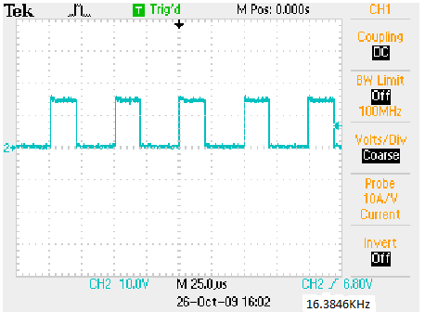

- Waveforms across TP11 w.r.t TP2 (Gnd) on PCB: -
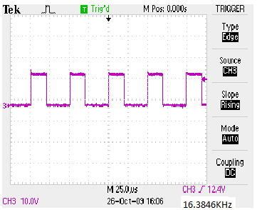

- Waveforms across TP10 and TP11 w.r.t TP2 (Gnd):
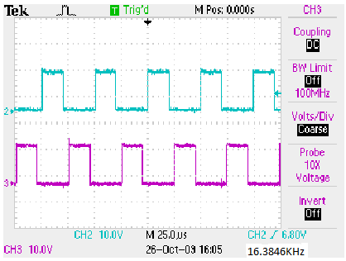

- Waveforms @ G1&E1, G2&E2, G3&E3, G4&E4: -
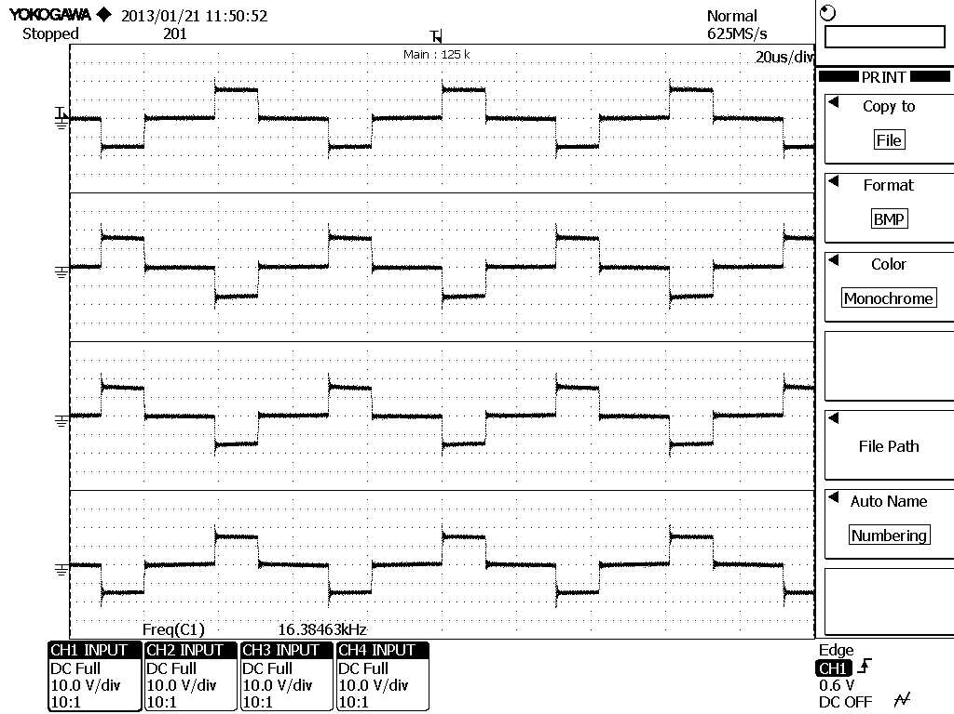
G1&E1
G2&E2
G3&E3
G4&E4

